Student Review

This was made by the Fall ’14 Honors Physics Class. Sections are by topic. For keys: refer to the section in red above each subsection.

Constant Velocity and Position Time Graphs

Section 1

1. Identify what the following slopes represent.
   * Slope of a position-time graph
   * Slope of a velocity-time graph
2. Identify what the following will give you.
   * Area under an acceleration-time graph
   * Area under a velocity-time graph
3. A car travels down a road going 40 m/s.
   * Plot the position vs time graph for 10 seconds
   * Plot the velocity vs time graph for 10 seconds
   * Find the displacement between the 5th and 10th seconds.
4. A train travels down a track going 45 m/s.
   * Plot the position vs time graph for 10 seconds
   * Plot the velocity vs time graph for 10 seconds
   * Find the displacement between the 5th and 10th seconds
5. What is the acceleration when there is constant velocity?
6. A sloth has an average speed of .037 m/s, and a turtle walks at .076 m/s. After 12 minutes, how much further would the turtle have gone relative to the sloth?
7. What is the equation for solving problems with constant velocity?

|  |  |
| --- | --- |
| Time | Position |
| 1 | 20 |
| 5 | 100 |
| 7 | 140 |
| 10 | 200 |

1. Sketch the position time graph and find the position at t = 3.
   * What is the slope?
2. A shark swims eastward for a distance of 6.9 km. It turns around and goes West for 1.8km, and finally turns around and heads 3.7km East
   * What is the total distance traveled by the shark?
   * What is the displacement?
3. A giraffe has an average speed of 2 m/s while on the run. An elephant has an average speed of 1.35 m/s while on the run. After 14 minutes, how much further would the giraffe have gone relative to the elephant?

Horizontal 1-D Kinematics and Velocity-Time Graphs

Section 2

1. What is the slope of a velocity-time graph represent?
2. What is the area under the velocity-time graph represent?
3. Given the time vs. displacement graph below, create a velocity vs. time graph.
4. Given the following time vs. velocity graph, what is the acceleration between 2 and 3 seconds?
5. For the above graph, where is the magnitude of the acceleration the greatest?

**Horizontal 1-D Kinematics**

1. A bowling ball is thrown down a 20m lane at 3.7 m/s. It hits the pins going 2.5 m/s. how long does it take the bowling ball to get to the pins? What is the acceleration of the ball?
2. A plane starts from rest and begins take off at 12 m/s^2. It needs to reach 170 m/s in order to take off. If the runway is 1,500m long, is the plane able to take off?
3. A golf ball hit off a tee reaches 70 m/s after 0.04s. What is the acceleration of the ball?
4. A car starts from rest and takes 15 seconds to travel 50m at an acceleration of 2 m/s^2. How fast is the car going after 50m?
5. If a car is going 45 m/s for 10 seconds, how far does it travel?

Vertical 1-D Kinematics

Section 3

1. **Upton Chuck is riding the Giant Drop at Great America. If Upton free falls for 2.60 seconds, what will be his final velocity and how far will he fall?**
2. **A feather is dropped on the moon from a height of 1.40 meters. The acceleration of gravity on the moon is 1.67 m/s2. Determine the time for the feather to fall to the surface of the moon.**
3. **A kangaroo is capable of jumping to a height of 2.62 m. Determine the takeoff speed of the kangaroo.**
4. **If Michael Jordan has a vertical leap of 1.29 m, then what is his takeoff speed and his hang time (total time to move upwards to the peak and then return to the ground)?**
5. **A baseball is popped straight up into the air and has a hang-time of 6.25 s. Determine the height to which the ball rises before it reaches its peak.**
6. **What is an objects acceleration at its peak height?**
7. **What is an objects velocity at its peak height?**
8. **A stone is dropped into a deep well and is heard to hit the water 3.41 s after being dropped. Determine the depth of the well.**
9. **The observation deck of tall skyscraper 370 m above the street. Determine the time required for a penny to free fall from the deck to the street below.**
10. **What is the direction of the acceleration of a bullet shot straight up into the air?**

Velocity-Time Graphs with Constant Acceleration

Section 4

1. In a velocity-time graph, the acceleration is the
2. If the slope of a graph is 0, acceleration is
3. In free-fall graphs, the acceleration in the y-direction is and remains
4. Using the data given in the table, is the acceleration constant?

|  |  |
| --- | --- |
| Time (s) | Velocity (m/s) |
| 0 | 0 |
| 1 | 4 |
| 2 | 8 |
| 3 | 12 |

1. A bug jumps off of the Empire State Building, and he hits the ground with a final velocity of -588 m/s after 60 seconds. What is the bug’s acceleration?

Use the graph for questions 6-10

[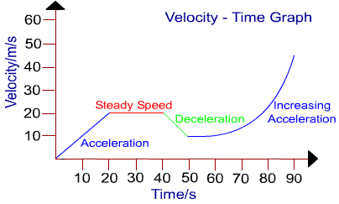](http://www.google.com/url?sa=i&rct=j&q=&esrc=s&frm=1&source=images&cd=&cad=rja&uact=8&ved=0CAcQjRw&url=http://askmichellephysics.blogspot.com/2012/03/movement-and-position.html&ei=S0u1VP_sFoSLgwSo2ILwBA&psig=AFQjCNG6qGTvUzIxdo4beYG_S0pJvA0kNw&ust=1421253832907674)

1. What is the area under the line/slope of a velocity-time graph?
2. What interval(s) have constant acceleration?
3. What interval(s) don’t have constant acceleration?
4. What is the acceleration between 0-20 seconds?
5. What is the acceleration between 40-50 seconds?

Newton’s 1st and 3rd Laws of Motion

Section 5

1. An 8 kg box is moving horizontally with a speed of 17 m/s. How much force is needed to keep the object in motion?
2. If you were in a completely weightless place, such as space, would a force have to be exerted in order to set an object in motion?
3. If one object is harder to push than another object, you can conclude that the object that is harder to push is…
4. A 5 kg ball is rolling on a frictionless floor, how much force is required to keep it in motion?
5. If an object weighs 10Kg then what is its normal force?
6. If forces are balanced then…?
7. Mr. Breish high-5s Dennis with a force of 30N. What is the force that is exerted on Mr. Breish’s hand as he slaps Dennis?
8. The force on Mr. Breish’s hand is what in comparison to Dennis’s hand?
9. A baseball is hit with a force of 10N, what is the force that the ball exerts on the bat?
10. Mr. Breish is bowling and needs to save spare on the last frame. However, there’s a 7- 10 split that he needs to knock down. If he’s aiming at the left pin, where would be the ideal spot to strike the pin in order to knock down the pin on the other side of the lane?

Newton’s 2nd on a Flat Surface

Section 6

1. Mr. Breish gets a flat tire and has to push his 1500 kg car back to his house. He is able to push it 0.2 m/s^2. Find out how much force he is applying to the car?
2. Mr. Breish is pulling his wife on a skateboard through the park. Their combined weight is 55 kg and is pulling with a force of 15 N. Find the acceleration.
3. Mr. Breish becomes a pilot and flies a 10000 kg plane that accelerates at of 135 m/s^2 during take off. Find how much force is being applied to the plane?
4. Mr. Breish driving a 450 kg Ice Cream Truck with a force of 870 N and has to stop in 2 meters to avoid hitting an infant. Find his negative acceleration to avoid running over the infant.
5. Mr. Breish becomes a professional pool player and needs to hit the 1 kg cue ball at an acceleration of 2.5 m/s^2 to make the game winning shot. Find the force applied on the ball.
6. Mr. Breish becomes a professional hockey player in Russia and hits the puck with a force of 20 N and it travels towards the back of the net at a speed of 40 m/s^2. Find the weight of the puck.
7. Mr. Breish decides to get his nose pierced. The force of the needle goes through his ears with 5 N of force and it weigh 2 kg. Find the acceleration of the needle.
8. Mr. Breish sees a bus full of children broken down on train tracks just as a train is approaching. He runs over and pushes the bus with a force of 400 N and at an acceleration of 7 m/s^2. Find   
   the weight of the bus.
9. Mr. Breish goes outside in a blizzard so he can build a snowman, he rolls the giant ball to the bottom of the snowman at an acceleration of 3 m/s^2, the giant ball of snow weighs 15 kg. Find the force being applied to the snow.
10. Mr. Breish becomes a professional golfer and enters the PGA Tour, he couldn’t get a caddy so he has to pull his 20 kg golf bag with a force of 30 N. Find the acceleration of the bag.

Newton’s 2nd on an inclined Plane

Section 7

1. A 10 kg crate is sliding down a hill with a 25 degree incline. Sketch the free body diagram, and determine the acceleration of the tire. (Ignore air resistance)
2. In the following diagram, a 50 g box is sliding down a frictional surface at a constant speed of 0.5 m/s. If the incline angle is 40 degrees, what is the force of friction?
$${40}^{o}$$

3. Three students are solving a physics problem, and they can’t decide which one of them is right. Sally thinks the normal force is 500 N, Matt thinks the normal force is 433 N, and Steven thinks the normal force is 250 N. All of them are reasonable, but only one is correct. Solve the problem to find which one is correct, and explain why the other two are wrong.

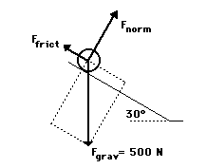

1. A 75 kg box is sliding down a frictional surface at a speed of 0.6 m/s. The incline angle is 15 degrees. Draw a free body diagram and solve for the force of friction.
2. If the mass of an object on an inclined plane is 10 kg, and the force of friction is 80 N, what is the normal force? Draw a free body diagram to go along with your answer.
3. If the normal force on a 20kg box sliding down a frictional plane with an incline of 65 degrees is 150 N, what is the force of friction? Draw a free body diagram to go along with your answer.

Circular Motion

Section 8

1. If a disc has a radius of 0.04m and spins at 7000rpm, what is the speed of the edge of the disc?
2. A plane flies 300km/hr what is the max radius the plane can go in a loop for the rider to be able to stay on top of the plane?
3. A person doing the hammer throw swings the 4kg hammer. The length of the hammer is 1.2m and the thrower is able to throw it around one rotation every 3s. What is the tension on the hammer?
4. A boy sits 2 m away from the center of a carousel. If it makes a revolution every 6 seconds, what is the centripetal acceleration of the boy?
5. The radius of a gravitron is 7m. If a 100 kg person goes onto the ride, what is the maximum period if the coefficient of friction is 0.5?
6. A car drives around in a circle with a radius of 15m. If the cars velocity is 13m/s, what is the centripetal acceleration of the car?
7. A barrel ride has a radius of 10m. The barrel spins 30 times/min and then the bottom drops out. What is the minimum coefficient of static friction needed for a 100kg rider to not fall out?
8. A cylindrical amusement park ride has a radius of 2m. If the mass of the rider is 93 kg and $μ$ is 0.7, what is the minimum speed needed for the rider to stay suspended when the floor drops?

2-D Kinematics: Horizontal Trajectory and Δy=0

Section 9

1. A small child is shot at a 40 degree angle at an initial velocity of 30 m/s. How far away will the child land? (no change in y)
2. A watermelon is hit at a 58 degree angle at 65 m/s. How far away did the melon land? (no change in y)
3. Determine the landing point of Mr. Breish when thrown at an angle of 37 degrees with an initial velocity of 26 m/s. (no change in y)
4. A piece of toast is thrown at 69 degrees with an initial velocity of 12 m/s. How far away will it land?(no change in y)
5. A baby travels 300 meters after being shot out of a cannon with the initial height of 1.7 meters above the ground. What is the initial velocity of the baby? (horizontal projectile)
6. Barack Obama is flying 1152 meters above the ground with a velocity of 102 m/s. Where would Barack land?(horizontal)
7. A cheese-puff leaves a ramp at 35 m/s and land 65 meters from the base of the ramp. How high is the ramp from the landing area? (horizontal )
8. A kumquat rolls with a velocity of 3 m/s across a 2 meter tall table. How far away from the table would the kumquat fall? (horizontal)

Work, Power and Energy

Section 10

1. What is the equation for work?
2. What is the equation for power? What are the units?
3. When is θ=0?
4. What is the equation for kinetic energy?
5. What is the equation for gravitational potential energy?
6. What is µ? What is the equation for this?
7. A busser carries 16kg load of dishes upstairs. The dishes have 4m vertical displacement and 7m horizontal displacement. What is the potential energy put into the dishes?
8. A 6kg mass is dragged 6m across the floor at a constant speed. If µ=.5, how much work does the pull on the object do?
9. What has more power? A person lifting 50kg 1m above the ground in 2 seconds or 150kg 4m above the ground in 20 seconds?
10. An engine needs 3500N of force to maintain a velocity of 20 m/s. What is its power rating? (1hp=746 watts)

Electricity

Section 11

Series Circuits

1. A series circuit has a total voltage of 15 volts and requires 9 amps in the current. What is the resistance?
2. A flash light requires 1100 watts of power. If the plug supplies 120 volts, what is the current of the wave?
3. A coffee pot has 3 resisters with 3 ohms, 5 ohms, and 14 ohms. Also 12 amps on the current. What is the total voltage?

Parallel Circuits

1. An electric frying pan has a total voltage of 147. If the circuit has two parallel resisters, one being 13ohms and one is 15ohms, what is the total current?
2. A cell phone charger has an electrical current of 20 amps. If it has three resisters at 127,135, and 176 ohms what is the total voltage?
3. A hairdryer has a total voltage of 1200 volts. If there are two resisters at 150 ohms and 194ohms, what is the current of the hairdryer?

Combo Circuits

1. A 20v battery is connected in series to a 4ohm register. The circuit then connects to a 13 and 16 ohm resister in parallel. What is the total resistance of the circuit?
2. The total voltage of the current is 12volts. The circuit connects to a 6 and 5 ohm resister in parallel and a 2 and 3 in series. What is the power of the battery?
3. The total current in a circuit is 22amps. There is 2 and 3ohms resisters in parallel and 12 and 15 ohms in series. What is the power of the battery?
4. There is a battery with a power of 28 volts. The resisters are 13, 16, and 5 ohms with 1 and 16 ohms being in parallel. What is the total current?

Answer Keys:

Constant Velocity and Position Time Graphs

Section 1- See also Graphs on pdf

1. A. Velocity B. Acceleration
2. A. change in velocity B. displacement
3. C. 200m
4. C. 225m
5. 0
6. 28.08m
7. V= Delta X/ T
8. At t=3, s = 60 Slope = 20
9. A. 12.4 km B. 8.8 km east
10. 546m

Horizontal 1-D Kinematics and Velocity-Time Graphs

Section 2

1. Acceleration
2. Displacement
3. 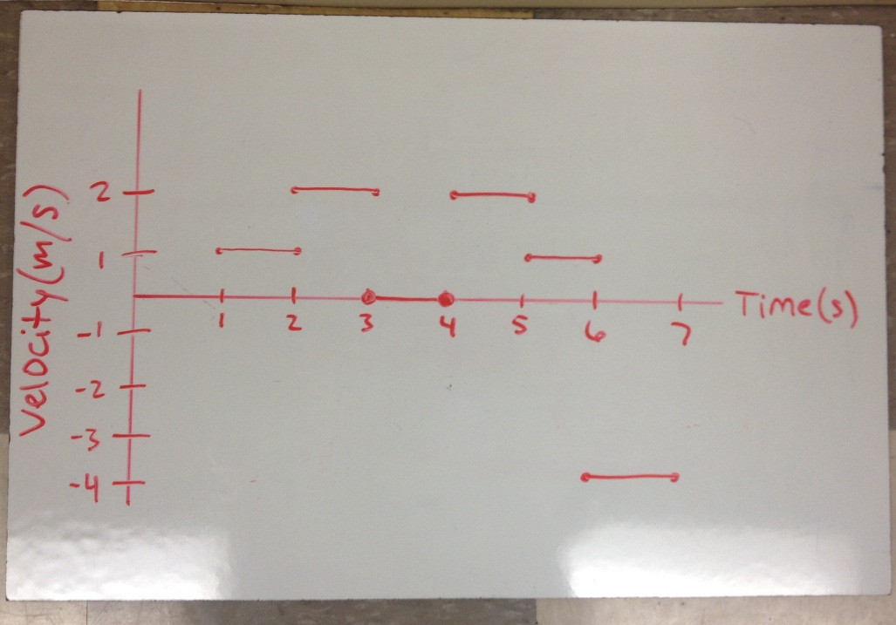
4. 2 m/s^2
5. Between 6 and 7 seconds

Horizontal 1-D kinematics

1. t=6.45s, a= -0.186m/s^2
2. t=14.2s, x= 1207
3. a=1750m/s^2
4. Vf= 6.67m/s
5. X=450m

Vertical 1-D Kinematics

Section 3

1. **d = 33.1 m and vf = 25.5 m/s**
2. **t = 1.29 s**
3. **vi = 7.17 m/s**
4. **5.03 m/s and hang time = 1.03 s (except for in sports commercials)**
5. **d = 48.0 m**
6. **-9.8 m/s**
7. **0 m/s**
8. **57 m**
9. **8.69 sec**
10. **Downward**

Velocity-Time Graphs with Constant Acceleration

Section 4

1. Slope
2. 0
3. -9.8 m/s^2, constant
4. Yes
5. -9.8 m/s^2
6. Displacement
7. 0-20, 20-40, 40-50
8. 50-90
9. 1 m/s^2
10. -1 m/s^2

Newton’s 1st and 3rd Laws of Motion

Section 5

1. An 8 kg box is moving horizontally with a speed of 17 m/s. How much force is needed to keep the object in motion?
   1. None, “an object in motion tends to stay in motion”
2. If you were in a completely weightless place, such as space, would a force have to be exerted in order to set an object in motion?
   1. Yes
3. If one object is harder to push than another object, you can conclude that the object that is harder to push is…
   1. More massive than the other
4. A 5 kg ball is rolling on a frictionless floor, how much force is required to keep it in motion?
   1. a0N
5. If an object weighs 10Kg then what is its normal force?
   1. 98N
6. If forces are balanced then…?
   1. It must not be accelerating OR it is moving at a constant velocity
7. Mr. Breish high-5s Dennis’s with a force of 30N what is the force that is exerted on Mr. Breish’s hand as he slaps Dennis?
   1. 30N
8. The force on Mr. Breish’s hand is what in comparison to Dennis’s?
   1. The same
9. A baseball is hit with a force of 10N, what is the force that the ball exerts on the bat?
   1. 10N
10. Mr. Breish is bowling and needs a to save spare on the last frame. However, there’s a 7- 10 split that he needs to knock down. If he’s aiming at the left pin, where would be the ideal spot to strike the pin in order to knock down the pin on the other side of the lane?
    1. The left side

Newton’s 2nd on a Flat Surface

Section 6

1. 300 N
2. .27 m/s^2
3. 1350000 N
4. -1.93 m/s^2
5. 2.5 N
6. .5 kg
7. 2.5 m/s^2
8. 57.1 kg
9. 45 N
10. 1.5 m/s^2

Newton’s 2nd on an inclined Plane

Section 7

1. A 10 kg crate is sliding down a hill with a 25 degree incline. Sketch the free body diagram, and determine the acceleration of the tire. (Ignore air resistance)

A= 8.88 m/ $s^{2}$

$${25}^{o}$$

FN

Ff

Fg

10 kg

1. In the following diagram, a 50 g box is sliding down a frictional surface at a constant speed of 0.5 m/s. If the incline angle is 40 degrees, what is the force of friction?

Ff= 0.38N

$${40}^{o}$$

FN

Ff

Fg

50 g

1. Three students are solving a physics problem, and they can’t decide which one of them is right. Sally thinks the normal force is 500 N, Matt thinks the normal force is 433 N, and Steven thinks the normal force is 250 N. All of them are reasonable, but only one is correct. Solve the problem to find which one is correct, and explain why the other two are wrong.



Matt is correct.

Sally is incorrect because Fg is not

equal to Fn.

Steven is incorrect because he

used sine instead of cosine

1. A 75 kg box is sliding down a frictional surface at a speed of 0.6 m/s. The incline angle is 15 degrees. Draw a free body diagram and solve for the force of friction.

$${15}^{o}$$

FN

Ff

Fg

Ff=710N

75 kg

1. If the mass of an object on an inclined plane is 10 kg, and the force of friction is 80 N, what is the normal force? Draw a free body diagram to go along with your answer.

FN

Ff

Fg

Fn= 18 N

10 kg

1. If the normal force on a 20kg box sliding down a frictional plane with an incline of 65 degrees is 150 N, what is the force of friction? Draw a free body diagram to go along with your answer.

$${65}^{o}$$

FN

Ff

Fg

Ff= 46N

20 kg

Circular Motion

Section 8

1. 29.32 m/s
2. 708.6 m
3. 20.84 N
4. 2.205 m/s^2
5. 3.75 s
6. 11.26 m/s^2
7. 0.1
8. 2 s

2-D Kinematics: Δy not 0

Section 9

1. 90.42 m
2. 386.96 m
3. 66.26 m
4. 9.8 m
5. 509.32 m/s
6. 1560.6 m
7. -4410 m
8. 1.91 m

Work, Power and Energy

Section 10

Work, Power and Energy Answers

1. What is the equation for work?

W= (force)(displacement)(cos θ)

1. What is the equation for power? What are the units?

Power=work/time

Joules per second or watts

1. When is θ=0?

When force and the direction of the object are moving in the same direction

1. What is the equation for kinetic energy?

KE= 1/2mv2

1. What is the equation for gravitational potential energy?

GPE=mgh

1. What is µ? What is the equation for this?

The coefficient of friction

Ff/FN or Friction/the Normal Force

1. A busser carries 16kg load of dishes upstairs. The dishes have 4m vertical displacement and 7m horizontal displacement. What is the potential energy put into the dishes?

627.2 N

1. A 6kg mass is dragged 6m across the floor at a constant speed. If µ=.5, how much work does the pull on the object do?

176.4 J

1. What has more power? A person lifting 50kg 1m above the ground in 2 seconds or 150kg 4m above the ground in 20 seconds?

The second person

1. An engine needs 3500N of force to maintain a velocity of 20 m/s. What is its power rating? (1hp=746 watts)

93.8 hp

Electricity

Section 11

. R=1.66

2. I=9.16

3. V tot=258

4. A=21.1

5. V=954.1

6. A=14.19

7. R tot=2.57

8. P=42

9. V=25.3

10. A=1.43